Secure login and register web project using vanilla php

Navigate to your MySQL Serve and create a database named Authentication

Copy the SQL command below and paste it in the SQL Tab on your PHPMyAdmin control Panel

CREATE TABLE `users` (

`id` int(11) NOT NULL,

` first_name ` varchar(100) NOT NULL,

` last_name ` varchar(100) NOT NULL,

` password ` varchar(100) NOT NULL,

`hash` varchar(100) NOT NULL)

After pasting this click GO

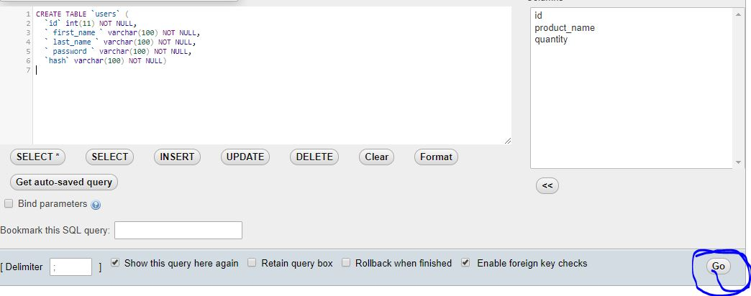

Now the database and the required table has been created

You can now navigate and start using the app

[localhost/ login-system/index.php](http://localhost/%20login-system/index.php)

You can start registering users and generally testing the app as you wish.